**Objective**: At the end of this lab session you will learn about Nested Queries where Sub queries return more than one value.

**Nested Query Part 2**

Section 1

Syntax:

SELECT column_name [,column_name]

FROM table1 [, table2 ]

WHERE [join condition AND] column_name OPERATOR (SELECT column_name [, column_name ]

FROM table1 [, table2]

[WHERE]);

If the subquery returns more than one row as a result then one of the following multiple-row

comparison operators have to be used, along with any of the single-row comparison operators we discussed in the last lab sheet (Nested Query part 1).

|  |  |
| --- | --- |
| Operator | Meaning |
| IN | Equal to any member in the list |
| ANY | Compare value to each value returned by the subquery |
| ALL | Compare value to every value returned by the subquery |

Section 2

Example Question:

What are the course names that the number of credits less than ISE course modules???

So, first, we need to write the subquery to find the number of credits in the ISE course modules. There are 4 modules in the ISE course. Each module has Number of credits in the module table and to get Course Id we have to join Offers table Mcode with the Module table Mcode.

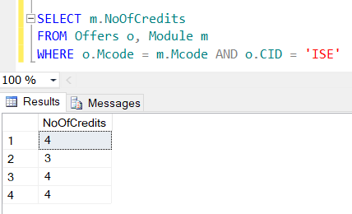

In the main query, we joined three tables because we need to get the course names and we need to find the course names less than the no of credits in the ISE module. So, No of credits in the Module table and Course name in the Course table, we can’t join those 2 tables because there is no foreign key. So, we need to get the help of the offer table as well to join these 2 tables.

SELECT c.Cname

FROM Module m, Course c, Offers o

WHERE m.Mcode = o.Mcode AND c.CID = o.CID AND m.NoOfCredits

Now we need to find the course which has less credit module than the ISE course modules. Here we get multiple results in the subquery. So we need to use ‘ALL’ because we need to check all the results in the subquery.

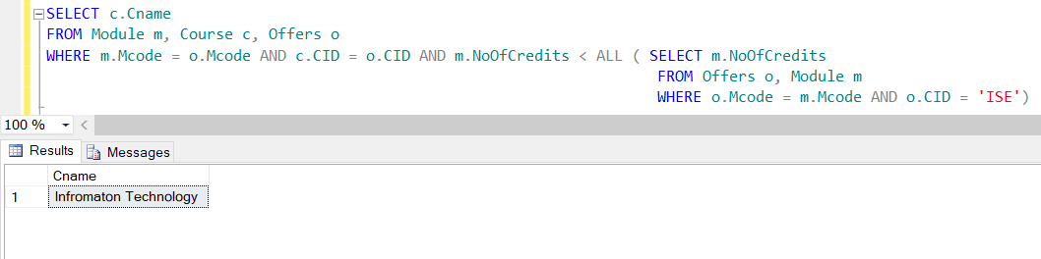

Exercise

1. What is the name of the course with the highest registration fee?
2. What are the names of modules common to both ‘Software Engineering’ and ‘Information Technology’?
3. What are the names of modules offered by ‘Software Engineering’ program but not in ‘Information Technology’?